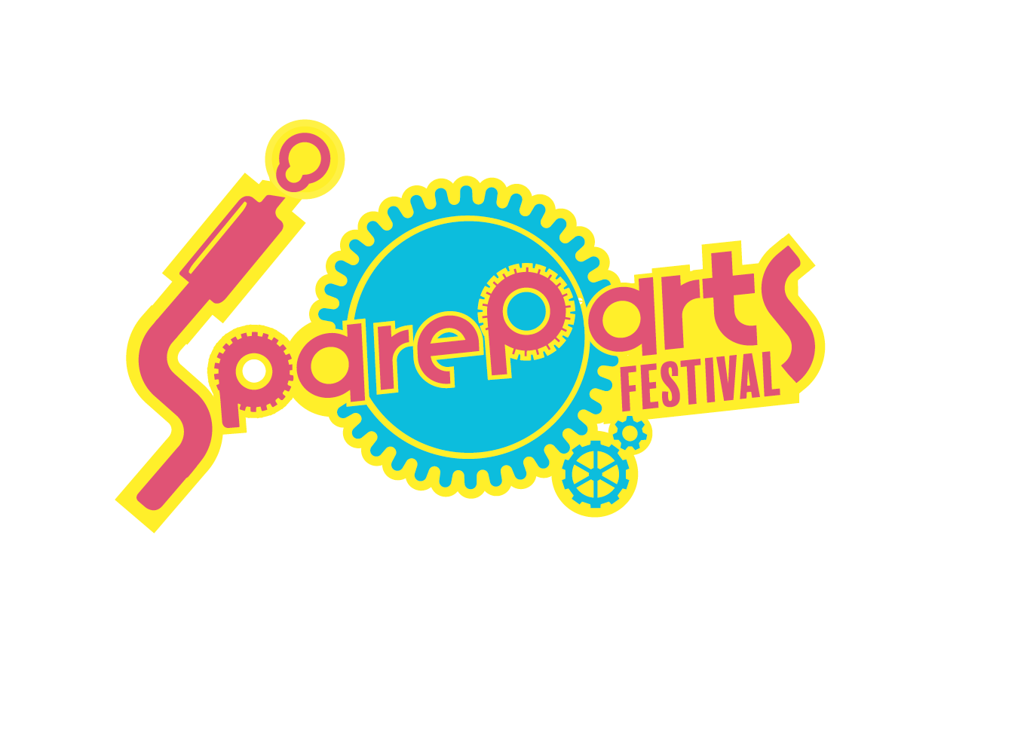

SpareParts Festival – Marketing Officer

Are you passionate about helping to transform the cultural landscape in the North of England? SpareParts is a unique transport inspired festival created in Fleetwood. It has developed out of an innovative partnership between Fleetwood Festival of Transport, LeftCoast and Wyre Council.

The Festival aims to use existing transport festivals as a platform to engage those who don’t usually see the arts as ‘for them’ using dynamic and exciting programming and participation.

After a successful strategic touring pilot in 2017 the project was developed with ACE, Cheshire East Council, Crewe Town Council and Sandbach Transport Festival to create SpareParts: Accelerate; a 3 year touring programme reaching 3 festivals in 2018 and 5 transport festivals in the North West by 2020.

About the Role

Working under the direction of the Festival’s Marketing Manager you will be mainly responsible for the management of digital activity designed to drive audiences to the events taking place in Sandbach, Crewe and Fleetwood during 2018.

A self-starter with a flair for creating creative content, you’ll be able to use digital tools to deepen engagement with audiences and build a sense of excitement about the dynamic and exciting programme of outdoor arts the Festival delivers.

As well as leading on the delivery of the digital campaign you’ll also aid the Marketing Manager with sourcing quotes, arranging deliveries, responding to enquiries and working with the Festival partners to provide them with content.

Key responsibilities for this role include:

- Manage the SpareParts Festival social media channels including attending the Festival dates and providing live coverage
- Produce creative content that is imaginative and shows the dynamism of the Festival
- Update the Festival website
- Work with videographers to direct the production of and distribute ‘behind the scenes’ style content
- Source quotes from supplies, assist with artwork proofing and arrange deliveries within agreed timescales
- Share your learning with other members of the Festival team and contribute to the wider evaluation at the end of year 1
- Have an understanding and belief in engaging less engaged audiences in the arts
- Be a passionate advocate for the SpareParts Festival
- Any additional and appropriate tasks related to the delivery of the marketing and audience development campaign

Commission length and terms

1 March to 1 August 2018 – 25 days at £150 a day (approximately 1 day per week with extra days some weeks).

Following the first year of the project there will be an evaluation and subject to this the contract may be renewed for 2019 and 2020. Applicants must be self-employed and will be contracted to Fleetwood Festival of Transport. Payment will be made monthly.

How to apply
If you would like to have an informal discussion about this commission please contact Duncan Hodgson, SpareParts Marketing Manager, via duncan@duncanhodgson.co.uk

To apply please send a CV and covering letter about why you are interested and suitable for this role with examples of your previous work to duncan@duncanhodgson.co.uk marked as SpareParts Marketing Officer by Friday 16 February at 12 midday.
